21.32: a)
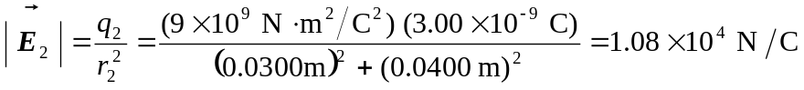

The angle of 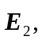 measured from the 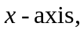 is 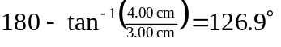 Thus
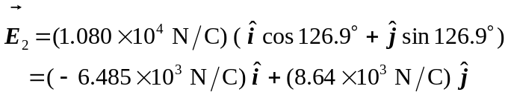

b) The resultant field is
